Chapter 03 - Intensity Transformations and Spatial Filtering

Table of Contents

Enhancement Techniques 3

Image Enhancement in the Spatial Domain 3

Contrast Stretching and Thresholding 4

Basic Transformation Functions 6

Identity Function 6

Negative Function 7

Log Transformations 7

Power Law Transformations 9

Piece-Wise Linear Transformation Functions 10

Gray-Level Slicing 10

Bit-Plane Slicing 11

Histogram Processing 13

Transformation Functions 14

Probability Density Functions 15

Histogram Equalization 16

Spatial Filters 18

Histogram Specification 19

Local Histogram Equalization 20

Arithmetic and Logical Operations 21

Temporal Averaging 23

Spatial Filtering 23

Image Smoothing 24

Median Filter 26

Sharpening Filters 27

Unsharp Masking 31

Gradient Masks 31

## Enhancement Techniques

The objective of **enhancing** an image is to process the image so that it is more suitable for a specific application. What suitable means depends on the application. An enhancement method which is very useful for one application may not be that good for another.

How good an image is depends on the situation. If we are considering the quality from the perspective of a machine, the evaluation task is easier since there are quantitative metrics. From the human perspective, the evaluation becomes subjective and harder to standardize. Generally, there is at least some trial and error before an enhancement approach is selected.

## Image Enhancement in the Spatial Domain

If the enhancement techniques are based on direct manipulation of pixels of an image, they are said to work on the **spatial domain**. If they are based on modifying the **Fourier transform** of an image, they are said to work on the **frequency domain**.

In the spatial domain, for an input image $f\left(x,y\right)$, the processed image $g\left(x,y\right)$ is given by

$$g\left(x,y\right)=T\left[f\left(x,y\right)\right]$$

where $T$ is an operator.

The operator $T$ might operate over a region centered at $\left(x,y\right)$, in which case it is called **area processing**, or on the specific pixel at $\left(x,y\right)$, in which case it is called **point processing**.

The equation can also be written as $s=T\left(r\right)$, where $s=g\left(x,y\right)$ and $r=f\left(x,y\right)$.

## Contrast Stretching and Thresholding

In **thresholding**, our objective is to turn a grayscale image into a binary one. We pick some intensity value $m$ and map all the pixels below this intensity value to $0$ and all the pixels above this intensity value to $255$. We are using $255$ instead of $1$ here to make the visualization easier. In reality, a black and white image only has $0$ s and $1$ s.



Thresholding is easier to understand, but in reality, it is an extreme form of a different technique called **contrast stretching**. Consider the graph below:



We have taken all of the pixels with intensity values up to some point $\frac{L}{4}$ and mapped them to a point slightly below $\frac{L}{4}$. We have also taken all of the pixels with intensity values above some point $\frac{3L}{4}$ and mapped them to a point slightly above $\frac{3L}{4}$. In between these two points, the values get stretched out. Thus, for those pixels the contrast goes from being between $\frac{L}{4}$ and $\frac{3L}{4}$ to being between $<\frac{L}{4}$ and $>\frac{3L}{4}$. This is why the technique is called **contrast stretching**.

Since we are increasing the contrast for these specific pixels, we will be able to see them better. However, there is a catch. In order to do this, we are compressing another set of pixels. The pixels with intensity values between $0$ and $\frac{L}{4}$ and between $\frac{3L}{4}$ and $L$, are said to undergo **contrast compression**. This makes the contrast for those pixels worse, thus making them harder to visualize.

## Basic Transformation Functions

The concept of contrast stretching can be expanded to include several types of functions. Which range of intensity values get stretched depends not only on the values of $a$ and $b$ that we choose, but also on the **function** we choose. The graph below shows a few possibilities.

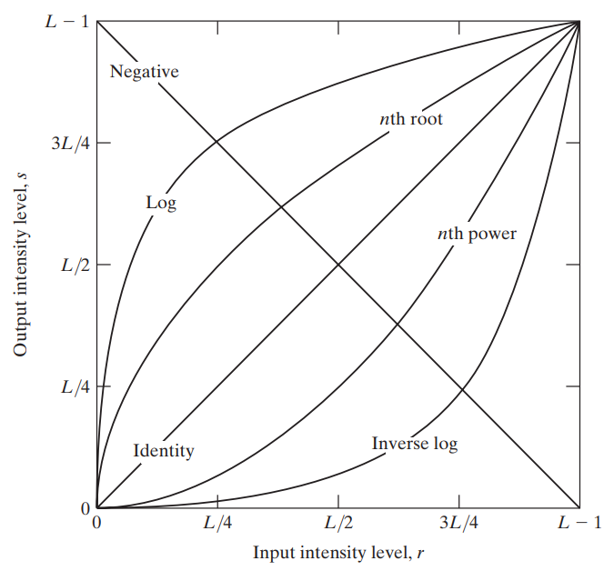

### Identity Function

The **Identity Function** is not really a transformation but is included as a reference point. It shows the change in intensity values when we apply the identity function, which is no change at all.

### Negative Function

The **Negative Function** is the result of applying $s=255-r$. It creates a negative image. Negative images improve visualization in cases where there is a small amount of white or grey detail in a large amount of black.

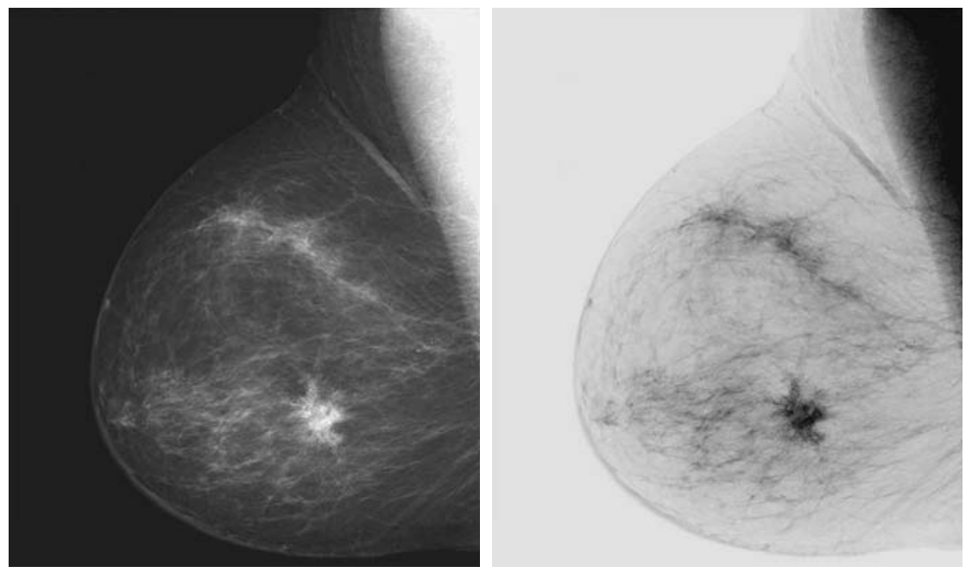

### Log Transformations

This is where things start to get interesting. The graph shows that applying a **logarithmic function** results in the intensity values everywhere increasing, but the degree of increase varies. The **lower intensity** values are **stretched** while the **higher intensity** values get **compressed**. This means that the contrast will improve for darker regions of an image and make it easier to see them while the contrast worsens for brighter portions.

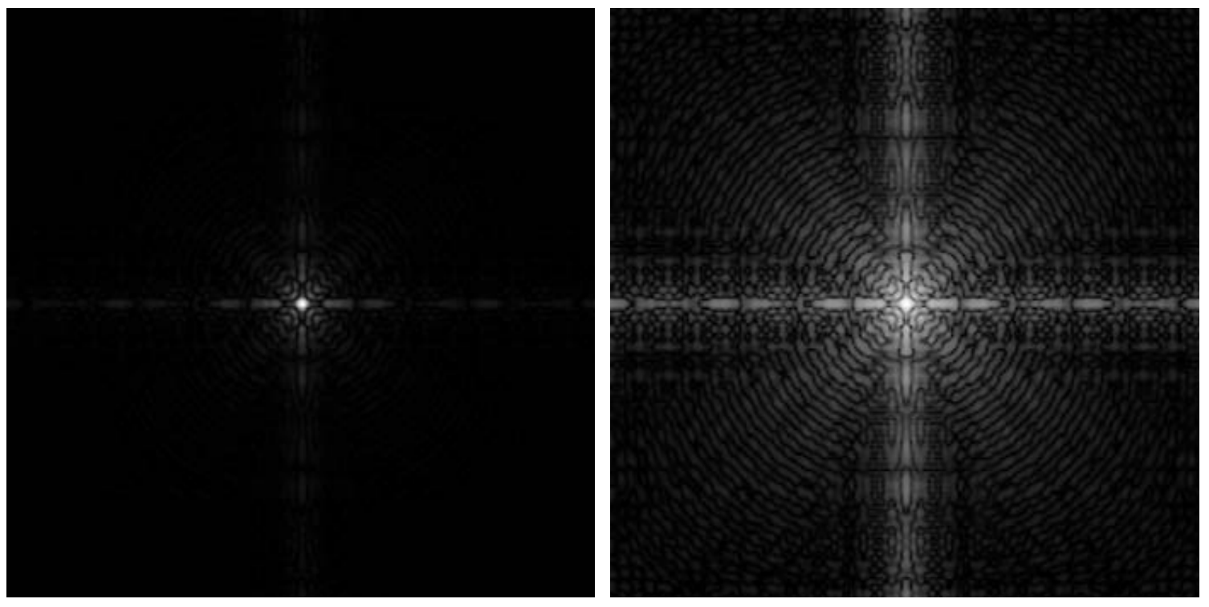

Log transformation is achieved by using the following formula:

$$s=c\log\left(l+r\right)$$

We have two variables here, $c$ and $l$. $l$ is a small value that is used to avoid the **negative infinity** that the logarithm function will give us in cases where $r=0$. $c$ is used for **scaling** purposes. The logarithm function itself will not give us values in the range of $0$ and $255$. To bring the values to this range, we perform scaling. As a reminder, scaling is achieved using the following function:

$$c=\frac{s-s_{min}}{s_{max}-s_{min}}×255$$

The direct opposite of this can be achieved using an **inverse log transformation**. This results in the **higher intensity** values getting stretched while the **lower intensity values** are compressed. As a result, we are able to see the brighter parts of an image better.

### Power Law Transformations

In the graph, the **power law transformations** are labelled as $n$ th power and $n$ th root. This is just a generalization of the logarithmic and inverse logarithmic functions. Instead of restricting ourselves to powers and roots of $10$ or $e$, we can use any value. The only difference this will give us is the degree to which one region is compressed and another is stretched.

The power law transformation can be achieved using:

$$s=cr^{γ}$$

If the value of $γ$ is larger than $1$, we get an effect like that of the inverse log transformation. If the value of $γ$ is smaller than $1$ (but always positive), we get an effect like that of the log transformation.

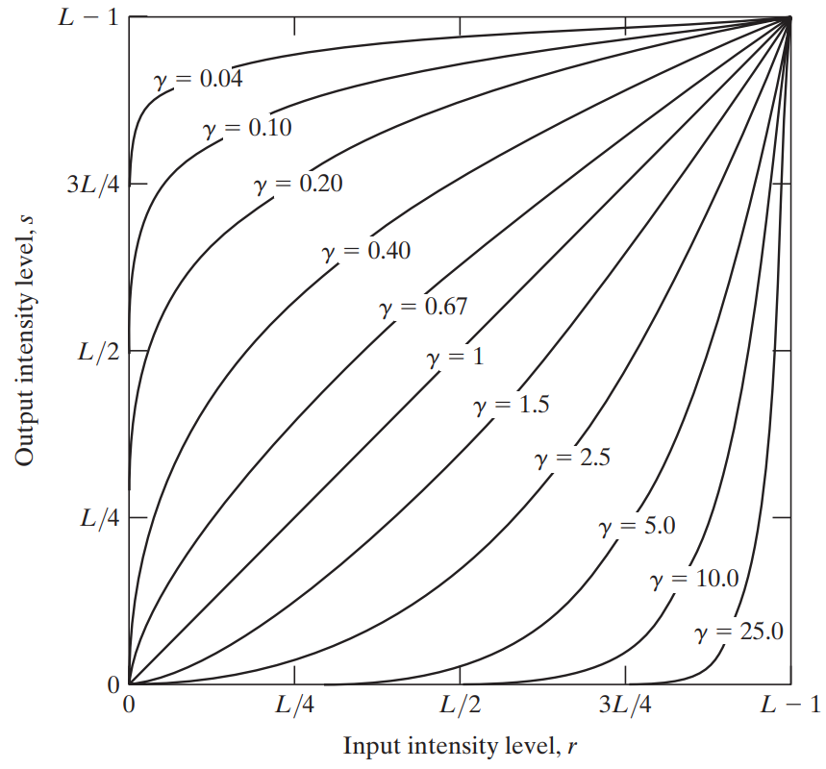

Generally, the power law transformation is called **gamma correction**. Monitors sometimes fail to show the true image due to hardware limitations. For example, the true image could be shown with lower overall intensities. This is as though the monitor is applying the power law transformation with $γ>1$. To combat this, we can apply the power law transformation with $γ<1$ before sending the image to the monitor. If we determine that the monitor uses $γ=4$, we can use $γ=\frac{1}{4}$ to cancel out the effect.

## Piece-Wise Linear Transformation Functions

We have already seen one example of a **Piece-Wise Linear Transformation Function**.



Such functions can be applied in a variety of places.

### Gray-Level Slicing

Suppose we have an image in which we want to highlight an object shown in one position. We somehow figured out that the intensity values for that object are between $A$ and $B$. To highlight this object, can just make everything else black while increasing the intensity between $A$ and $B$.

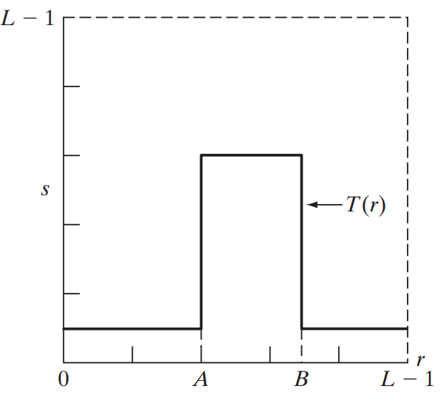

However, by doing this, we are losing the information everywhere else in the image. If we want to preserve that while still highlighting the main object, we can use the **identity function** everywhere except between $A$ and $B$, and increase the intensity between $A$ and $B$.

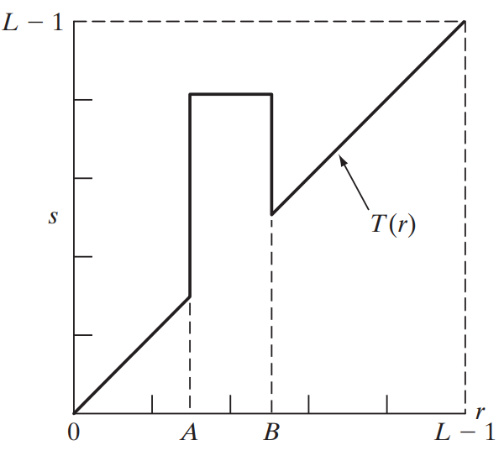

This entire process is called **gray level slicing**.

### Bit-Plane Slicing

**Bit-Plane Slicing** involves taking each of the bits from a pixel and transferring them onto its own plane. For 8-bits per pixel, we end up with 8 different planes, each of which show a binary image. This leads to an interesting observation. The diagram below shows an image along with each of the 8 planes created from that image, starting from the least significant bit (LSB) and going to the most significant bit (MSB).

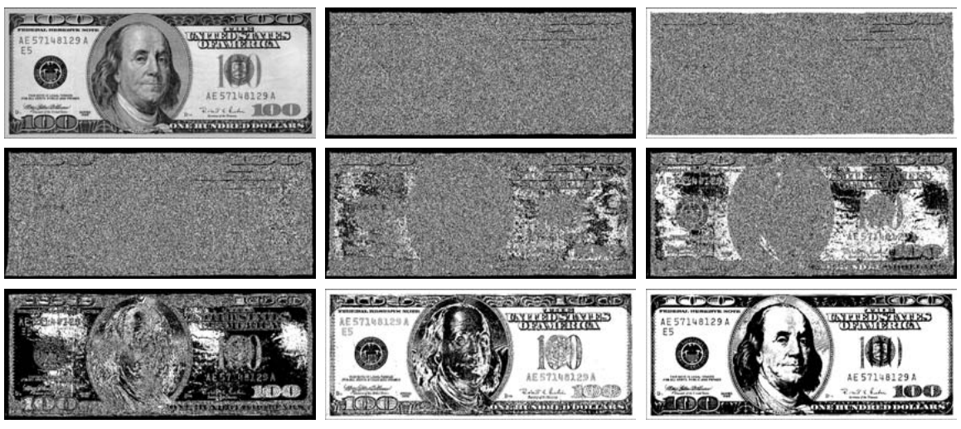

Clearly, the first 3 planes are noise. This happens because the **lower bits** describe much more **granular information** than the higher bits. For example, if the MSB changes from 1 to 0, that is a change of 127 in intensity for an 8-bit image. For the same image, the LSB changing from 1 to 0 is just a change of 1 in intensity. Thus, the higher bits are far more important than the lower ones.

This observation can give us a simple form of **image compression**, where we simple drop the last few bits when compressing the image, and replace them with 0s when decompressing the image. This compression will be **lossy**, since we are losing some information, no matter how minute.

The following figure shows the effect of dropping 6, 5 and 4 of the lower bits respectively. Depending on the use case, all of these images are practically indistinguishable from the original.

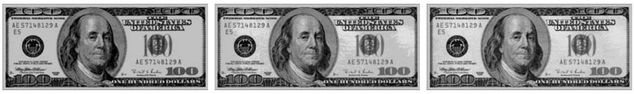

## Histogram Processing

The **histogram** of a digital image shows the frequency of pixels at each of the possible intensity levels, from $0$ to $L-1$. It is denoted as $h\left(r_{k}\right)=n_{k}$, where $r_{k}$ is the $k$ th intensity level and $n_{k}$ is the number of pixels in the image with that intensity.

Commonly, histograms are **normalized** by dividing each of the values of $n_{k}$ by $n$, the total number of pixels in the image.

$$p\left(r_{k}\right)=\frac{n_{k}}{n}$$

This gives us approximately the **probability** of the occurrence of the intensity value $r_{k}$ in the image.

Manipulating histograms can help us achieve **image enhancement**. For example, consider the images below, which show the effects of different histogram distributions. A histogram which has pixel counts concentrated on the lower, upper or middle range gives images with poor contrast. A histogram which is distributed somewhat evenly over the entire dynamic range has much better contrast.

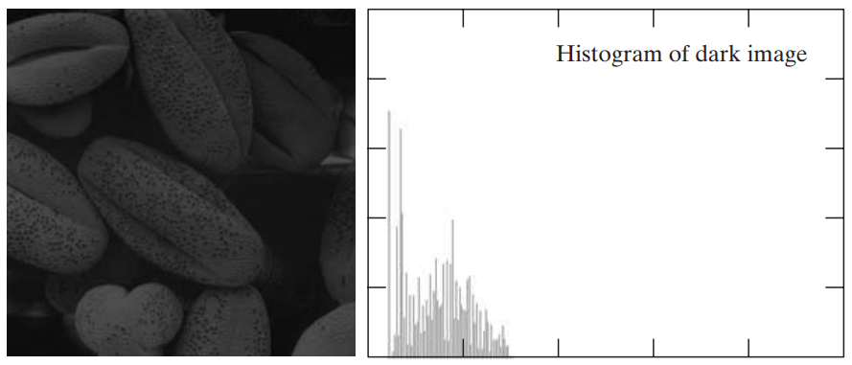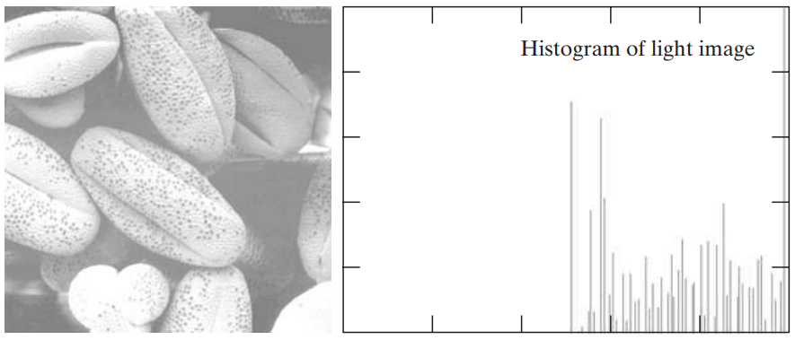

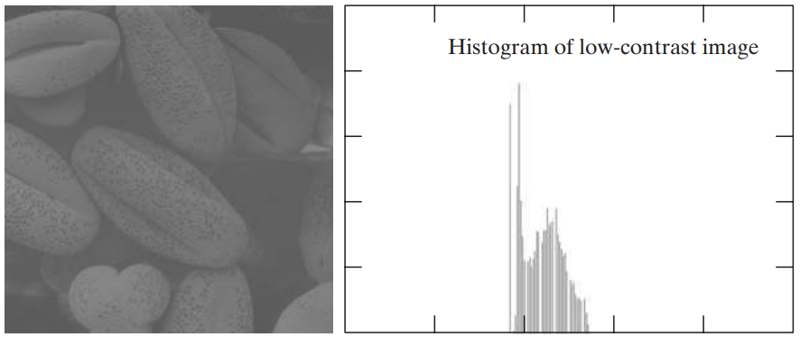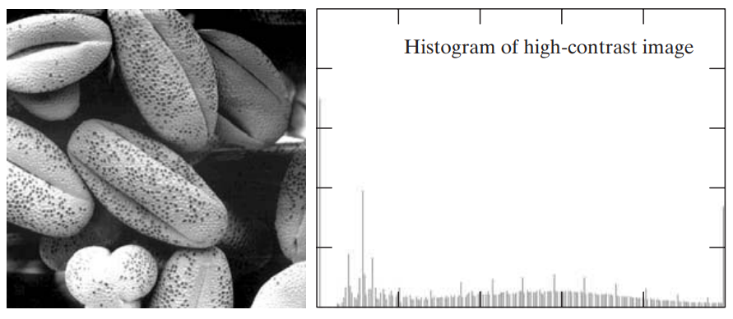

### Transformation Functions

Let $r$ be the range of intensity values from $0$ to $L-1$. For $r$, let us define a **transformation function**, $s=T\left(r\right)$. In order to make sure that we can produce an output intensity level $s$ for every pixel in the input image with intensity $r$, we have to make sure that:

* $T\left(r\right)$ is **monotonically increasing**, which means $T\left(r_{2}\right)≥T\left(r_{1}\right)$ for $r_{2}>r_{1}$.

$0≤T\left(r\right)≤L-1$

Sometimes, we will need to use the inverse, $r=T^{-1}\left(s\right)$, in which case $T\left(r\right)$ will need to be **strictly monotonically increasing**, meaning $T\left(r_{2}\right)>T\left(r_{1}\right)$ for $r_{2}>r_{1}$. The difference between the two terms graphically is shown below. Basically, a simple monotonic function will not allow us to identify a unique value of $r$ for every value of $s$, but a strictly monotonic one will.

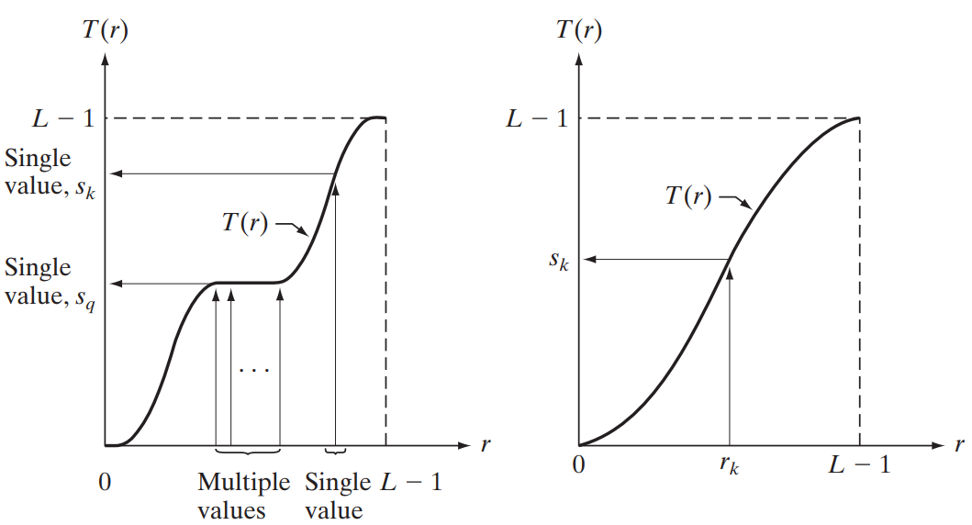

### Probability Density Functions

We can view the different intensity values for different pixels in an image as random variables. Viewing them as random variables allows us to use the definition of **Probability Density Functions** (PDFs). We can use this to define one of the fundamental transformation functions in image processing.

$$s=T\left(r\right)=\left(L-1\right)\int_{0}^{r}{p_{r}\left(w\right)dw}$$

where $p_{r}\left(w\right)$ is the PDF of $r$ for some value $w$ in the range of $0$ to $r$. The right side of this equation is just the **Cumulative Distribution Function** (CDF) of $r$. PDFs are monotonically increasing and fall into the range of $0$ and $L-1$, so they satisfy both conditions of being transformation functions. Additionally, they are basically the same thing as a **normalized histogram**.

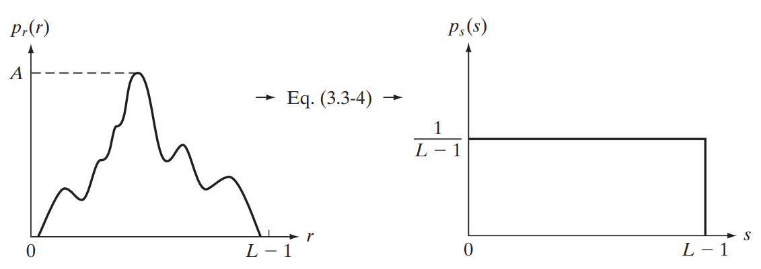

### Histogram Equalization

When dealing with discrete values (as in pictures), the probability of occurrence of the intensity level $r_{k}$ is approximated by

$$p_{r}\left(r_{k}\right)=\frac{n_{k}}{MN}$$

The discrete form of the transformation function is given by

$$s_{k}=T\left(r_{k}\right)$$

$$=\left(L-1\right)\sum_{j=0}^{k}{p_{r}\left(r_{j}\right)}$$

$$=\frac{\left(L-1\right)}{MN}\sum_{j=0}^{k}{n_{j}}$$

Applying this transformation to a histogram is called **histogram equalization**. By doing this, we can spread out a low-contrast image’s histogram to distribute it over a wider range, thus improving quality.

Example







## Spatial Filters

So far, we have concentrated on applying filters to images to transform them. If we centre the filter on the point $\left(x,y\right)$ and take a neighbourhood of size $m×n$, we are performing **area processing**. Using this, we can do things like computing the average of the values in the area to do something.

In the above case, we are working in the **space domain**. We can also work in the **temporal domain**. Suppose we capture $n$ images at the same position, each of size $m×n$, and compute the average value of the point $\left(x,y\right)$ over those $n$ images. This will give us **temporal averaging**.

For spatial filters, if we replace the values of pixels based on the average value in their surrounding neighbourhood, we will end up with an image which has **smoother** edges. This is because areas that are already smooth, i.e., ones without edges, will not have a significant change if we replace their values with the average of their neighbourhood. Only the edges will show a change. The larger the filter, the higher the degree of smoothing.

This also brings us to an interesting point. If we smooth an image and compute the difference between the original image and the smoothed image, we will find that the only places that show a difference are the edges. This provides us with a very rudimentary form of edge detection.

Suppose we have the following array of pixels in one dimension:

$$\left[\begin{matrix}… & 10 & 10 & 10 & 12 & 14 & 16 & 16 & 16 & …\end{matrix}\right]$$

If we apply the filter $\left[\begin{matrix}-1 & 0 & 1\end{matrix}\right]$ to each position, we can find the **gradient** at each position, the cell with the $0$ being the centre. This gives us the edge information.

$$\left[\begin{matrix}… & 0 & 0 & 2 & 2 & 2 & 2 & 0 & 0 & …\end{matrix}\right]$$

For a 2D image, instead of having a single value per cell, we will have a vector $\left[\begin{matrix}G_{x} \\ G_{y}\end{matrix}\right]$ at each cell, because we need gradients in two directions.

## Histogram Specification

Histogram equalization does not always produce a good result.

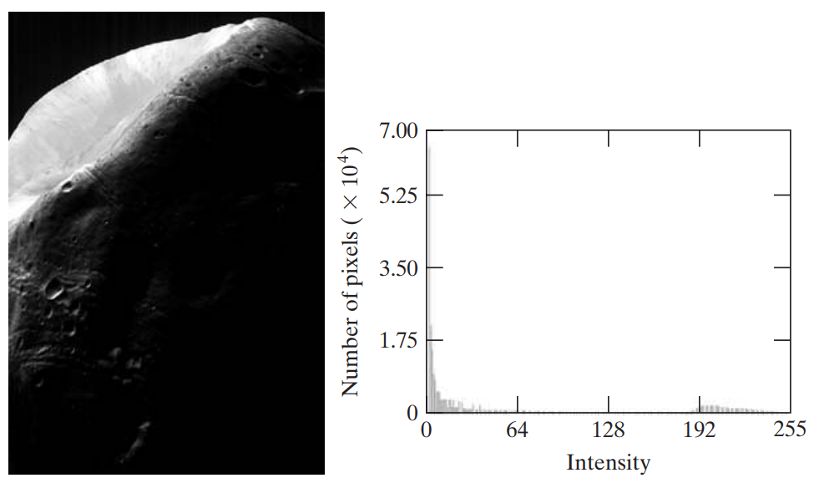

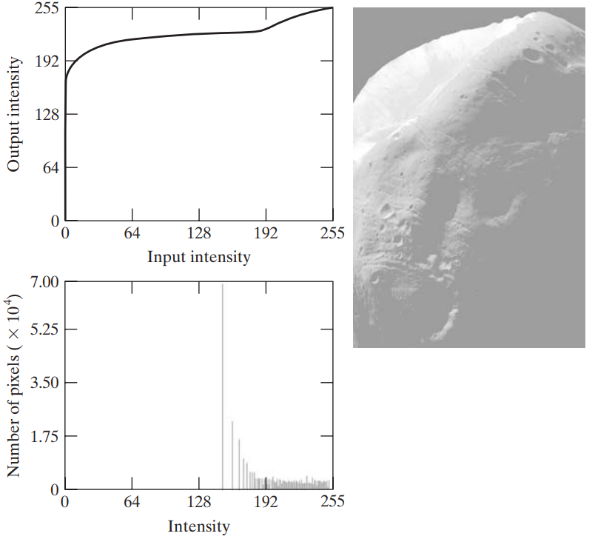

In these cases, we might be able to obtain a better result if we use **histogram specification**. This is when we specify the shape of the desired histogram manually and map the original histogram to the specified one. This requires some trial and error.

## Local Histogram Equalization

Instead of applying histogram equalization to the entire image at once, known as **global histogram equalization**, we can also use **local histogram equalization**. In this case, we divided the image into small patches and apply histogram equalization to each of those patches in turn. This results in smaller structures being enhanced, something which was not achievable using global histogram equalization due to the negligible impact of those small structures on the overall image.

The three images below show an original image, the effect of global histogram equalization and the effect of local histogram equalization respectively. Notice that only local histogram equalization is able to highlight the structure in the background to a large degree.

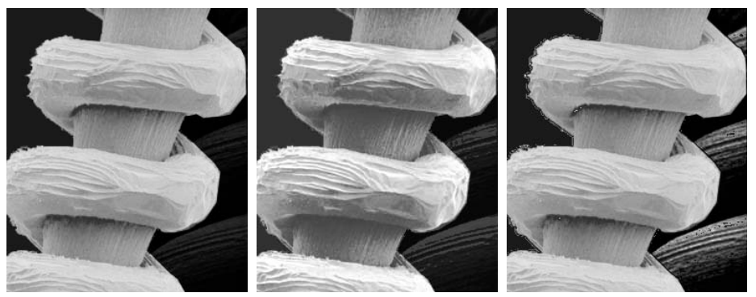

However, local histogram equalization also enhances **noise**. Notice that the third image is noisier around the edges of the main structure. This can sometimes lead to what is called the **blocking effect**.

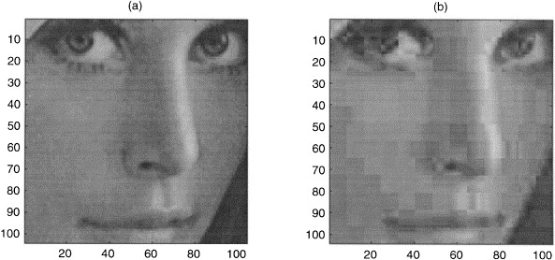

The blocking effect only occurs when we place the filter on non-overlapping blocks, i.e., for a filter of size $n×n$, we shift $n$ pixels to the right each time. If instead we shift the filter $1$ pixel to the right each time, using **overlapping blocks**, this issue will not appear.

## Arithmetic and Logical Operations

**Arithmetic or logical operations** can be performed pixel by pixel on two or more images. One exception is the **NOT** operation, which uses just one image. Logical operations work on **binary** images.

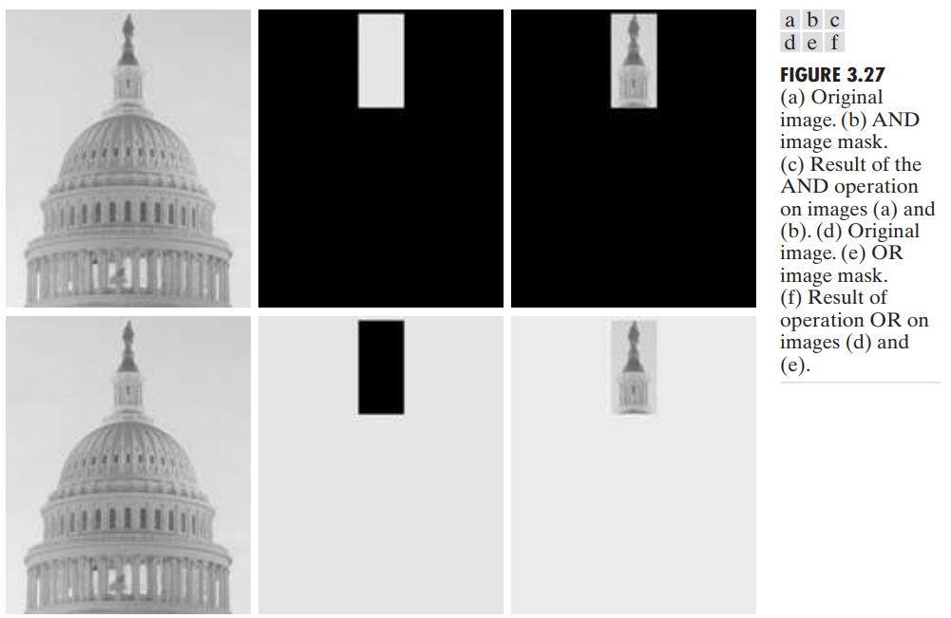

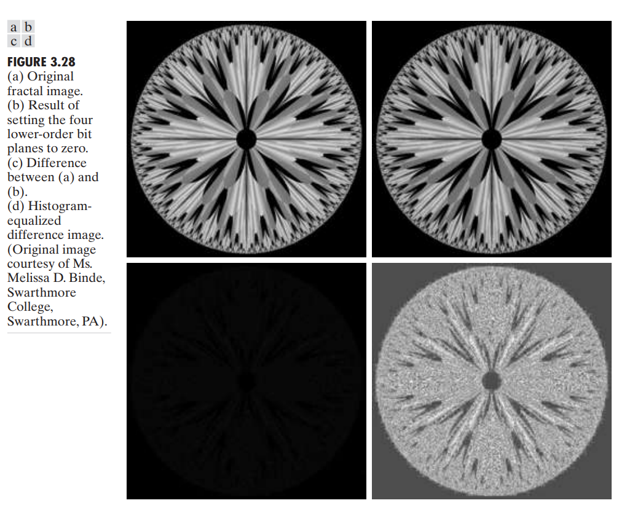

## Temporal Averaging

Another technique we can use to reduce noise is to average the images in the **temporal direction**. We take $k$ images of the same spot and take the average of them as the final image. This can reduce **gaussian noise**, which is noise with a $0$ mean.

## Spatial Filtering

The process of **Spatial Filtering** is similar to the convolution process used in Convolutional Neural Networks, where we place a filter on top of the image to calculate the output for a single cell.

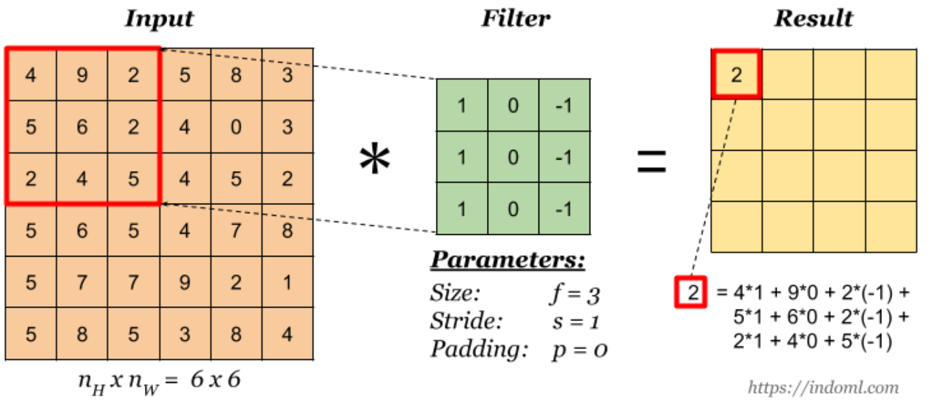

Remember that technically, the thing we are doing here is **correlation**. Convolution would require us to flip the filter by $180°$ before applying it. Imagine a 1D filter, $\left[\begin{matrix}3 & 7 & 4\end{matrix}\right]$, being applied to a 1D image, $\left[\begin{matrix}… & 0 & 0 & 0 & 1 & 0 & 0 & 0 & …\end{matrix}\right]$. The result is $\left[\begin{matrix}… & 0 & 0 & 4 & 7 & 3 & 0 & 0 & …\end{matrix}\right]$. Notice that the result flips the filter. This happens if we perform correlation. If we perform true convolution, which flips the filter before applying it, the result will be the original filter. The same scenario occurs for 2D filters.

Unlike CNN, in which the values in the filter are learnt by the model, our filters will have the parameters predefined by us. Other than this, the concepts are the same. We will also be using **zero-padding** to make sure the input and output images are of the same size.

## Image Smoothing

**Image Smoothing** is applied to blur the edges of an image and reduce noise. The output of applying a smoothing filter to a subsection of an image is the average of the pixels in that section. Thus, if one of the pixels contains noise, it gets smoothed out.

A similar effect occurs at the edges, where there is a large difference in pixel intensity values. The differences get spread out over the neighbors. For example, if the original image section has the values $\left[\begin{matrix}… & 0 & 0 & 0 & 90 & 90 & 90 & …\end{matrix}\right]$, the result of applying the filter $\left[\begin{matrix}\frac{1}{3} & \frac{1}{3} & \frac{1}{3}\end{matrix}\right]$ is $\left[\begin{matrix}… & 0 & 0 & 30 & 60 & 90 & 90 & …\end{matrix}\right]$.

The filter we applied above is called a **box filter**, which has the following fixed configuration for the 2D case.

$$\frac{1}{9}×\left[\begin{matrix}1 & 1 & 1 \\ 1 & 1 & 1 \\ 1 & 1 & 1\end{matrix}\right]$$

Essentially, it is a filter of 1s divided by the number of cells in the filter. The larger the filter, the stronger the smoothing effect.

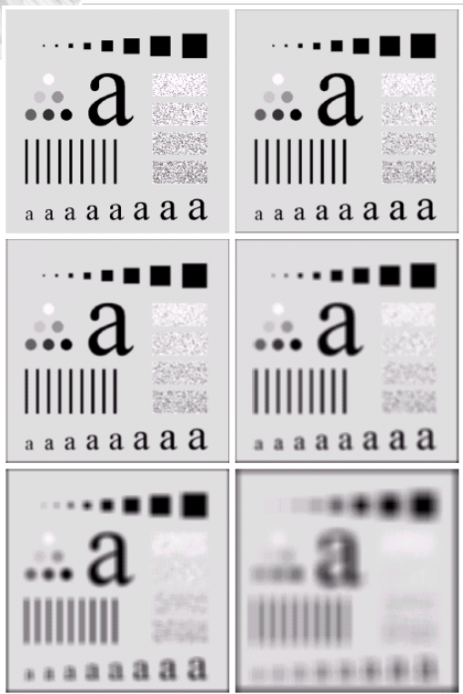

Notice that the borders are also becoming darker for the stronger filters. This is because **zero padding** has been applied and the larger filters show the effect of the zero neighbours on the edges more strongly.

The effect of using a $3×3$ filter twice on an image is nearly the same as the effect of using a $5×5$ filter once.

Instead of using a box filter, we can also use a **weighted average filter**, also called a Gaussian filter. This filter gives the highest weight to the centre, since that is the most important pixel in the section. It also gives higher weights to the 4 pixels on the top, bottom, left and right, since those are determined to be of the most importance to the central pixel. The sum of the weights must still add up to 1.

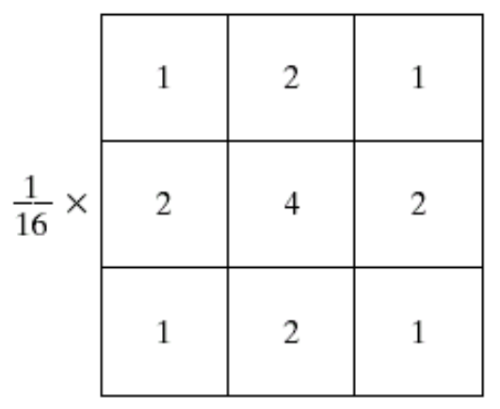

Using a weighted average filter makes the smoothing process less intense. The effect of using a $3×3$ box filter twice on an image is exactly the same as the effect of using a $5×5$ weighted average filter once.

## Median Filter

A **median filter** simply goes over the original image section by section and assigns the median value for a section to the central pixel of the section. It is a **non-linear filter**. Other non-linear filters include the max filter and the min filter.

Median filters work really well with certain types of noise, such as **impulse noise**, also called salt and pepper noise, due to the random pixels with 0 or 255 intensities that appear due to the noise. The median filter detects that these values are different from its neighbours (by calculating the median value), and assign the median value to them, thus removing the noise. A median filter is able to remove such noise without causing the edges of the image to become blurry, since the median value at the edges are the same. The edges do, however, tend to become larger.

If the amount of noise becomes too large (i.e., there are enough noisy pixels in a section for the noise to be the median in that section), the median filter will fail to remove all of the noise. In such a case, a larger filter can be used (since it becomes less likely that 50% of the pixels in a larger area will be noisy pixels). The failure due to a large amount of noise might also not occur in the case when the noise is salt and pepper noise, since a lot of the noise will cancel each other out when calculating the median.

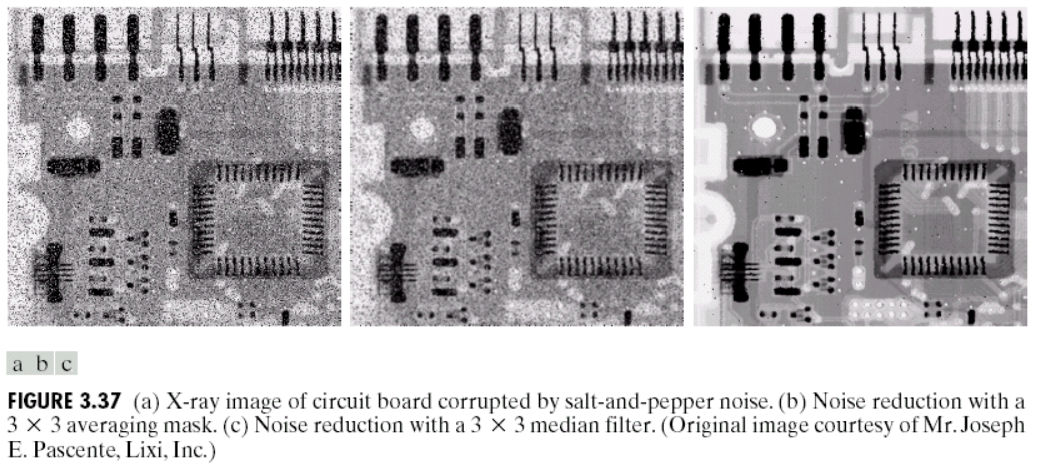

Despite not reducing contrast, a median filter is still technically a **smoothing filter**, since it is redistributing values (which is how it is reducing noise).

## Sharpening Filters

To sharpen the edges of an image, we must **increase the contrast** at the edges. We do this by increasing or decreasing the values just around the edges. However, to do that, we must first detect the edges. This is done using a **Laplacian filter**.

The **gradient** of pixel values is a good way to detect whether we are in a smooth region (where the gradient is constant) or at an edge (where the gradient changes). The gradient does not suddenly start changing, but rather changes slowly over several pixels. Thus, there is a ‘start’ and an ‘end’ to the edges. We can detect the points where the gradient starts and stops changing (thus the start and end of the edges) using the second order derivative. This is also called the **Laplacian**.

Suppose we have an image with intensity values as shown below:

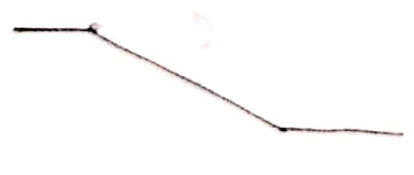

This image depicts an edge. It starts at the brighter end and goes to the darker end. The gradient response in this image is shown below:

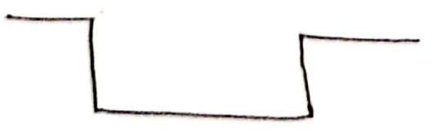

As can be seen, there is a negative, non-zero gradient at the ‘ramp’. The second order derivative, the Laplacian, is visualized as:

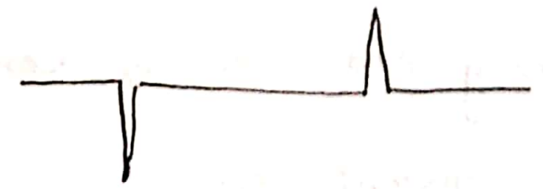

Thus, we get a strong negative response at the brighter end of the edge and a strong positive response at the darker end of the edge.

The Laplacian for the discrete case can be calculated as:

$$∇^{2}f=f\left(x+1,y\right)+f\left(x-1,y\right)+f\left(x,y+1\right)+f\left(x,y-1\right)-4f\left(x,y\right)$$

This equation can be viewed as a filter:

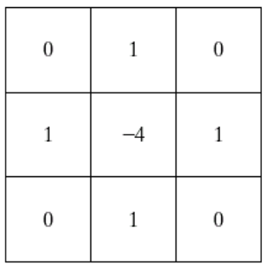

An alternative form that is also used is this:

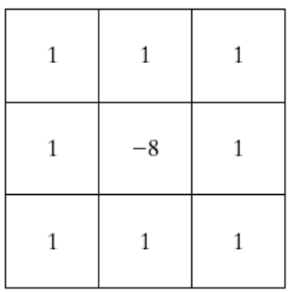

These filters are known as **isotropic filters**, which means there is no effect of rotation.

Applying these filters to an image will give us the **Laplacian response**, which is the edge information. From the graphs shown earlier, we know that the response will be negative at the brighter end and positive and the darker end. Thus, if we **subtract** the Laplacian response from the image, the value at the darker end will decrease a little and the value at the brighter end will increase a little. This change will happen just in the area immediately around the edge and will trick our eyes into thinking there is an increased contrast.

An alternative form of the filter can also be used so that we can **add** the response to the image instead of subtracting it.

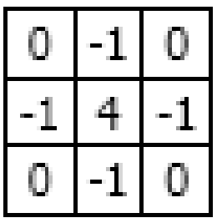

To simplify the operations of applying the filter and then adding the response to the image, we can also use this filter to do both operations at once:

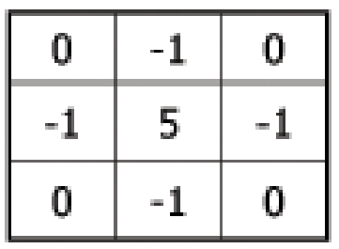

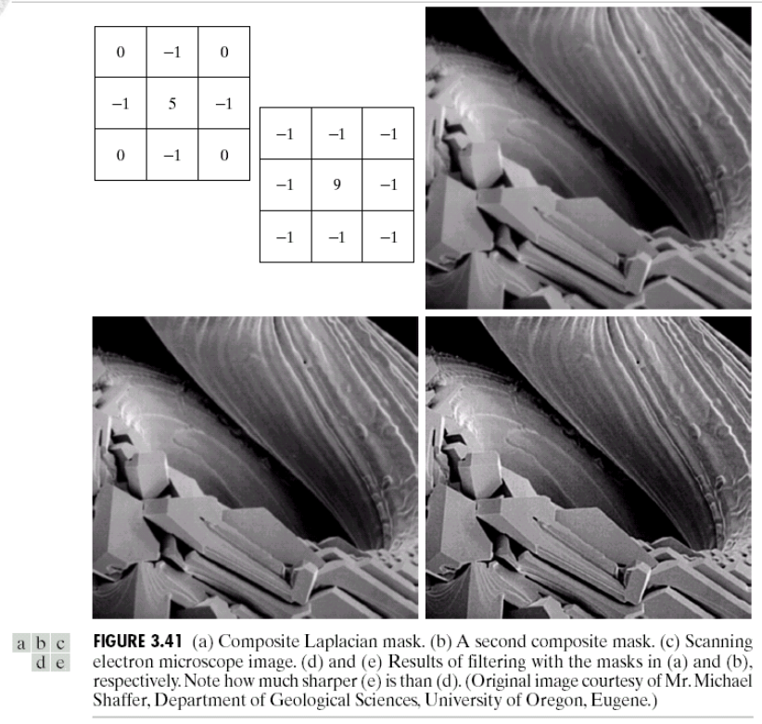

## Unsharp Masking

Another mechanism for edge detection that is popular in the print industry is called **unsharp masking**. In this technique, we create a blurred version of the original image and subtract the blurred version from the original. Since only edges are blurred, we end up getting non-zero values only at the edges. This edge information can then be added to the original image, thus giving a sharper image.

$$g_{mask}\left(x,y\right)=f\left(x,y\right)-\overline{f}\left(x,y\right)$$

$$g\left(x,y\right)=f\left(x,y\right)+g_{mask}\left(x,y\right)$$

An alternative form of this is called **high-boost filtering**, where we essentially add a multiple of the mask to the original image, giving increased sharpening.

$$g\left(x,y\right)=f\left(x,y\right)+k×g_{mask}\left(x,y\right)$$

## Gradient Masks

The **magnitude** of a gradient is given by:

$$mag\left(∇f\right)={\left[G_{x}^{2}+G_{y}^{2}\right]}^{\frac{1}{2}}≈\left|G_{x}\right|+\left|G_{y}\right|$$

The gradient itself is linear, whereas the magnitude of the gradient is not. The gradient is not isotropic, whereas the magnitude of the gradient is.

Based on these values, there are several masks, all of which use the configuration as shown below:

|  |  |  |
| --- | --- | --- |
| $$z_{1}$$ | $$z_{2}$$ | $$z_{3}$$ |
| $$z_{4}$$ | $$z_{5}$$ | $$z_{6}$$ |
| $$z_{7}$$ | $$z_{8}$$ | $$z_{9}$$ |

The simplest approximation we can have based on the gradient magnitude is:

$$G_{x}=\left(z_{8}-z_{5}\right)$$

$$G_{y}=\left(z_{6}-z_{5}\right)$$

$$∇f={\left[{\left(z_{8}-z_{5}\right)}^{2}+{\left(z_{6}-z_{5}\right)}^{2}\right]}^{\frac{1}{2}}$$

$$≈\left|z_{8}-z_{5}\right|+\left|z_{6}-z_{5}\right|$$

Similar to this, we also have the **Robert’s Cross-Gradient** mask:

$$G_{x}=\left(z_{9}-z_{5}\right)$$

$$G_{y}=\left(z_{8}-z_{6}\right)$$

$$∇f={\left[{\left(z_{9}-z_{5}\right)}^{2}+{\left(z_{8}-z_{6}\right)}^{2}\right]}^{\frac{1}{2}}$$

$$≈\left|z_{9}-z_{5}\right|+\left|z_{8}-z_{6}\right|$$

As a mask, the two parts of the above equation can be seen as:

|  |  |
| --- | --- |
| -1 | 0 |
| 0 | 1 |

|  |  |
| --- | --- |
| 0 | -1 |
| 1 | 0 |

Finally, we have the **Sobel** mask:

$$G_{x}=\left(z_{7}+2z_{8}+z_{9}\right)-\left(z_{1}+2z_{2}+z_{3}\right)$$

$$G_{y}=\left(z_{3}+2z_{6}+z_{9}\right)-\left(z_{1}+2z_{4}+z_{7}\right)$$

The mask can be visualized as:

|  |  |  |
| --- | --- | --- |
| -1 | -2 | -1 |
| 0 | 0 | 0 |
| 1 | 2 | 1 |

|  |  |  |
| --- | --- | --- |
| -1 | 0 | 1 |
| -2 | 0 | 2 |
| -1 | 0 | 1 |

Here, a higher weight is given to the central axes to achieve smoothing.

Notice that all of the masks above sum to 0, which means they will give a 0 response in smooth regions.